SQL Project Queries - Vancouver

a. Analyze different metrics to draw the distinction between Super Host and Other Hosts:

To achieve this, you can use the following metrics and explore a few yourself as well.

Acceptance rate, response rate, instant booking, profile picture, identity verified,

review review scores, average no of bookings per month, etc.

**1).In Following query we have calculated the count of host which are super host and host**

select count(*) from van_host where host_is_superhost='true'

select count(*) from van_host where host_is_superhost='false'  
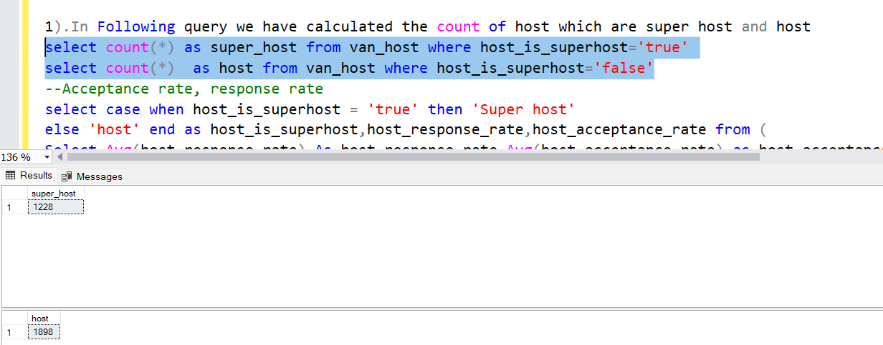

--Acceptance rate, response rate  
**1).In Following query we have found the variation in response rate and acceptance rate   
2). For Analysis we found Average of response rate and acceptance rate from host table and then grouped them.**

select case when host_is_superhost = 'true' then 'Super host'

else 'host' end as host_is_superhost,host_response_rate,host_acceptance_rate from (

Select Avg(host_response_rate) As host_response_rate,Avg(host_acceptance_rate) as host_acceptance_rate,

host_is_superhost from van_host

where host_response_rate is not null or host_acceptance_rate is not null group by host_is_superhost) as mo

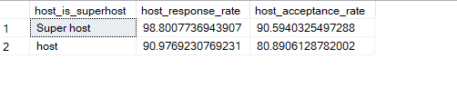

--profile picture  
1).for Analysis we found total number of super host and host who have profile picture .  
2) So from following output we can clearly see that 1225 out of 1228 super host have profile pic .

select case when host_is_superhost = 'true' then 'Super host'

else 'host' end as host_is_superhost,ct,cnt2 from (

select host_is_superhost,sum(true) as ct,sum(false)as cnt2 from(

select host_is_superhost,[TRUE],[FALSE] from van_host

pivot (count(host_id) for

host_has_profile_pic in ([TRUE],[FALSE]))a)a

where host_is_superhost is not null

group by host_is_superhost

) as mo  
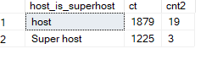

--identity verified  
1).for Analysis we found total number of super host and host whos identity has verified .  
2) So from following output we can clearly see that 1184 out of 1228 super host have identity verified .

select case when host_is_superhost = 'true' then 'Super host'

else 'host' end as host_is_superhost,verified,not_verified

from (

select host_is_superhost,sum(true) as Verified,sum(false)as Not_verified from(

select host_is_superhost,[TRUE],[FALSE] from van_host

pivot (count(host_id) for

host_Identity_verified in ([TRUE],[FALSE]))a)a where host_is_superhost is not null

group by host_is_superhost) as mo  
  
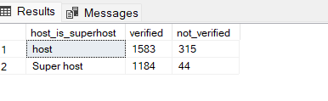

--instant booking  
1).for Analysis we found how many listing of super host and host are having option of instant booking   
2) Also in output if Value is true then then that hotel can be booked instantly.

select host_is_superhost, case when instant_bookable='false' then 'not bookable'

else 'bookable' end as instant_booking , count from (

Select B.Host_is_superhost,A.instant_bookable,Count(A.HOST_ID) AS count From van_list A Inner Join van_host B

ON A.HOST_ID = B.HOST_ID

where b.host_is_superhost is not null Group by Host_is_superhost,instant_bookable ) as mo   
  
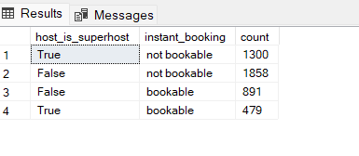

--review review scores

1) we found average of review score for host and super host.  
2) Where true is for super host and false for host.  
3)we can see from output that average score for super host are slightly greater than that for host.

Select B.Host_is_superhost,avg(A.review_scores_value) as review_scores_value

From van_list A Inner Join van_host B

ON A.HOST_ID = B.HOST_ID Group by Host_is_superhost  
  
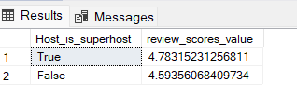

---Additional Analysis  
1st analysis

1). In following query we analyse the different ratings for listing under host and super host  
2). We found average rating for checkings,cleanliness,communication,location,score rating,  
3).Note that true is for super host and false for host

select b.host_is_superhost,avg(a.review_scores_checkin) as review_scores_checkin,

avg(a.review_scores_cleanliness) as review_scores_cleanliness,avg(a.review_scores_communication) as review_scores_communication

,avg(a.review_scores_location) as review_scores_location

,avg(a.review_scores_rating) as review_scores_rating ,avg(a.review_scores_value) as review_scores_value

from van_list as a inner join van_host as b on a.host_id=b.host_id

where b.host_is_superhost is not null

group by b.host_is_superhost;

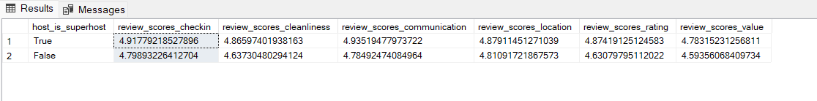  
  
**2nd analysis**  
1) here we found the total number of reviews for super host and host  
2) we can note from here that though super host count is less but they got higher reviews than host

select c.host_is_superhost,count(*) from van_review as a left join van_list as b on a.listing_id=b.id

left join van_host as c on b.host_id=c.host_id where c.host_is_superhost is not null

group by c.host_is_superhost;

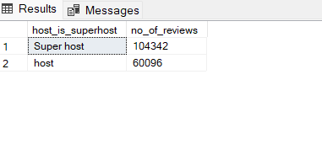  
3rd Analysis   
1) in this analysis we found how average of bedroomas and beds vary between super host and host.  
2)from output we can see that there is no significant difference between the

select b.host_is_superhost,avg(a.accommodates) as accommodates,avg(a.bedrooms) as bedrooms ,

avg(a.beds) as beds

from van_list as a inner join van_host as b on a.host_id=b.host_id

where b.host_is_superhost is not null

group by b.host_is_superhost;

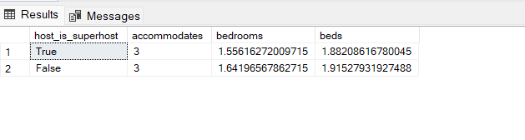

---b Using the above analysis, identify top 3 crucial metrics one needs to maintain to become a Super Host and also, find their average values

--Acceptance rate, response rate  
1). Using following parameter we can clearly see that if host improves these parameter he can become in super host

select case when host_is_superhost = 'true' then 'Super host'

else 'host' end as host_is_superhost,host_response_rate,host_acceptance_rate from (

Select Avg(host_response_rate) As host_response_rate,Avg(host_acceptance_rate) as host_acceptance_rate,

host_is_superhost from van_host

where host_response_rate is not null or host_acceptance_rate is not null group by host_is_superhost) as mo  
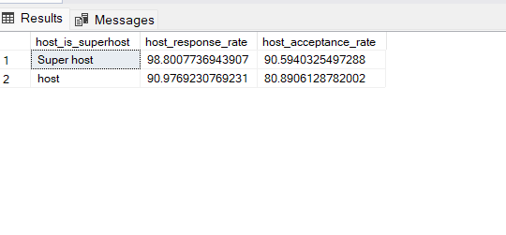

--identity verified

**select host_is_superhost,sum(true) as Verified,sum(false)as Not_verified from(**

**select host_is_superhost,[TRUE],[FALSE] from van_host**

**pivot (count(host_id) for**

**host_Identity_verified in ([TRUE],[FALSE]))a)a group by host_is_superhost**  
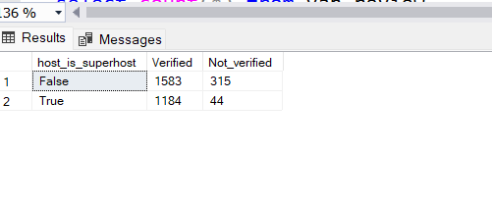

--c Analyze how does the comments of reviewers vary for listings of Super Hosts vs Other Hosts(Extract words from the comments provided by the reviewers)  
1) For Analysis we took few Positive comments such as beautiful,tastefull,perfect,amazing,very clean,recommended, very welcoming, guest host.

2) For Analysis we took few Negative comments such as a.comments like slow wifi,canceled, not recommended,unprofessional,not good,rude

select count(*) from van_review

--Positive Comment

select case when host_is_superhost = 'true' then 'Super host'

else 'host' end as host_is_superhost,review_count from (

select c.host_is_superhost,count( a.reviewer_id) as review_count from van_review as a left join van_list as b on a.listing_id=b.id

left join van_host as c on b.host_id=c.host_id

where (a.comments like '%beautiful%'or a.comments like '%tastefull%' or a.comments like '%perfect%'

or a.comments like '%amazing%' or a.comments like '%very clean%' or a.comments like '%gracious%'or a.comments like

'%recommended%' or a.comments like '%very welcoming%' or a.comments like '%best host%')and c.host_is_superhost is not null

group by c.host_is_superhost ) as mm  
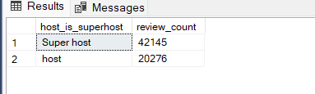

---Negative Comment

select case when host_is_superhost = 'true' then 'Super host'

else 'host' end as host_is_superhost,review_count from (

select c.host_is_superhost,count( a.reviewer_id) as review_count from van_review as a left join van_list as b on a.listing_id=b.id

left join van_host as c on b.host_id=c.host_id

where (a.comments like '%slow wifi%'or a.comments like '%canceled%' or a.comments like '%not recommended%'

or a.comments like '%unprofessional%' or a.comments like '%not good%' or a.comments like '%rude%'

) and c.host_is_superhost is not null

group by c.host_is_superhost ) as mo  
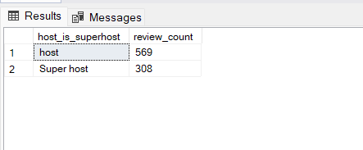

---d Analyze do Super Hosts tend to have large property types as compared to Other Hosts

1). In this analysis we sorted the property type on the basis of total accommodation  
2) We found average accommodation and selected the top 10 property type on basis of that.

select top 10 property_type,max(accommodates) from van_list

where accommodates > (select avg(accommodates) from van_list)

group by property_type

order by max(accommodates) desc  
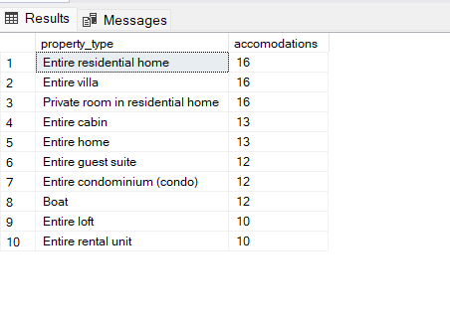

select count(distinct a.host_id) as property_of_superhost from van_host as a inner join van_list as b

on a.host_id=b.host_id where b.property_type in ('Entire residential home','Entire villa',

'Private room in residential home','Entire cabin','Entire home','Entire guest suite',

'Entire condominium (condo)','Boat','Entire loft','Entire rental unit')

and a.host_is_superhost = 'true'  
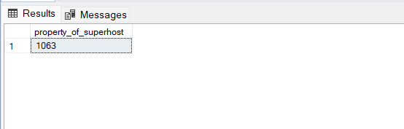

(select count(distinct a.host_id) as property_of_host from van_host as a left join van_list as b

on a.host_id=b.host_id where b.property_type in ('Entire residential home','Entire villa',

'Private room in residential home','Entire cabin','Entire home','Entire guest suite',

'Entire condominium (condo)','Boat','Entire loft','Entire rental unit')

and a.host_is_superhost = 'false')  
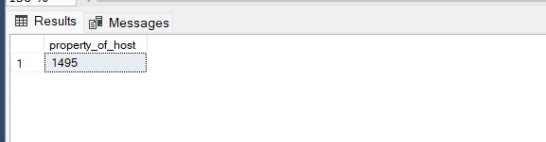

select count(*) from van_host where host_is_superhost = 'false'

---e Analyze the average price and availability of the listings for the upcoming year between Super Hosts and Other Hosts

1) In this analysis we found average price for host and super host for this year and upcoming year  
2)Also we found average availability for host and super host

--van avg price

Select* From(

Select C.host_is_superhost ,Round(AVG(A.adjusted_price),0) Avg_Price,year(Date) Upcom_Year

From van_avail A inner join van_list B on A.listing_id = B.id

inner join van_host C on B.host_id = C.host_id where A.available = 'true' and C.host_is_superhost is not null

Group By C.host_is_superhost,year(Date)) Z

Pivot(Avg(Avg_price) For host_is_superhost in ([True],[False])) As Pvt;

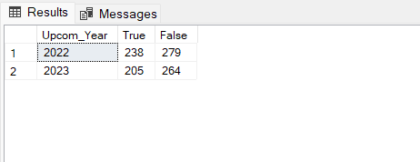

---van avilable and not availavle list

Select* From(

Select C.host_is_superhost,A.available ,Count(A.id) total_Available,year(Date) Upcom_Year

From van_avail A inner join van_list B on A.listing_id = B.id

inner join van_host C on B.host_id = C.host_id where C.host_is_superhost is not null

Group By C.host_is_superhost,A.available,A.listing_id,(Date)) Z

Pivot(Sum(total_Available) For host_is_superhost in ([True],[False])) As Pvt;

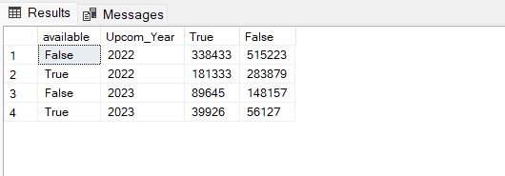

--f. Analyze if there is some difference in above mentioned trends between Local Hosts or Hosts  
1) For this analysis We considered local host whose location is same as neighbour location of its listing.  
2) And following analysis were made

--residing in other locations

select distinct HOST_NAME from (

select a.host_id,a.host_name,b.name ,a.host_neighbourhood from van_host as a inner join van_list as b on

a.host_id=b.host_id

where a.host_neighbourhood=b.neighbourhood_cleansed) as a  
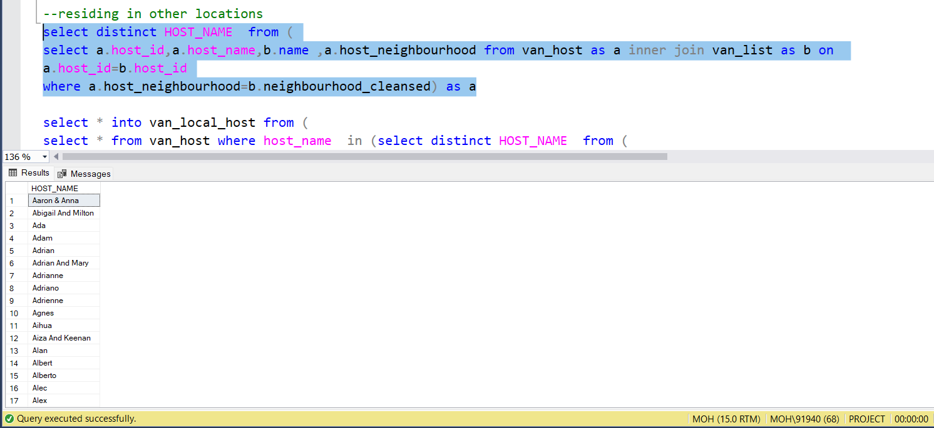

select * into van_local_host from (

select * from van_host where host_name in (select distinct HOST_NAME from (

select a.host_id,a.host_name,b.name ,a.host_neighbourhood from van_host as a inner join van_list as b on

a.host_id=b.host_id

where a.host_neighbourhood =b.neighbourhood_cleansed order by a.host_name) as a)) as mo

select * into van_other_host from (

select * from van_host where host_name not in (select distinct HOST_NAME from (

select a.host_id,a.host_name,b.name ,a.host_neighbourhood from van_host as a inner join van_list as b on

a.host_id=b.host_id

where a.host_neighbourhood =b.neighbourhood_cleansed) as a )) as mo

----

----- response rate

select avg(a.host_response_rate) from van_local_host

select avg(a.host_response_rate) from van_other_host   
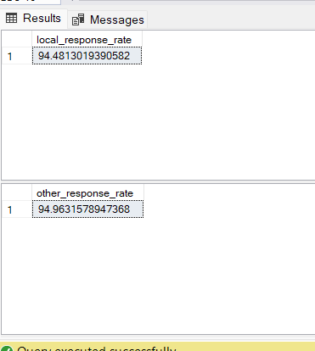

-----avg price

select avg(b.price) from van_local_host as a inner join van_list as b on a.host_id=b.host_id

select avg(b.price) from van_other_host as a inner join van_list as b on a.host_id=b.host_id  
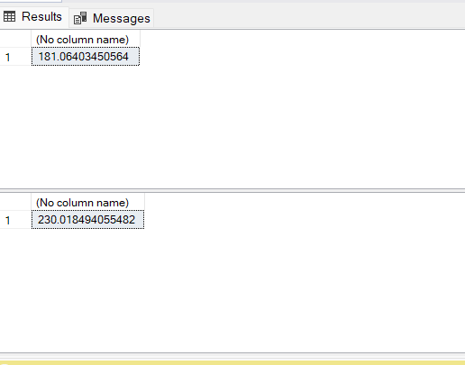

---avg rating

select avg(b.review_scores_accuracy) from van_local_host as a inner join van_list as b on a.host_id=b.host_id

select avg(b.review_scores_accuracy) from van_other_host as a inner join van_list as b on a.host_id=b.host_id  
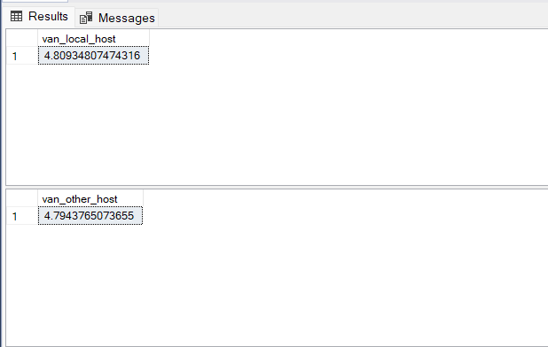

--supper host

select count(*) as number from (

select * from van_host where host_name in (select HOST_NAME from (

select a.host_id,a.host_name,b.name ,a.host_neighbourhood from van_host as a inner join van_list as b on

a.host_id=b.host_id

where a.host_neighbourhood =b.neighbourhood_cleansed ) as a)) as mo

where host_is_superhost='true'  
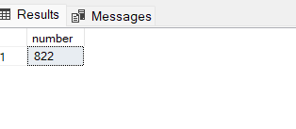

select count(*) as number from (

select * from van_host where host_name in (select HOST_NAME from (

select a.host_id,a.host_name,b.name ,a.host_neighbourhood from van_host as a inner join van_list as b on

a.host_id=b.host_id

where a.host_neighbourhood =b.neighbourhood_cleansed ) as a)) as mo

where host_is_superhost='false'  
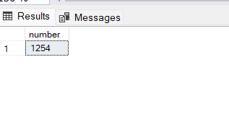

--host

select count(*) as number from (

select * from van_host where host_name not in (select HOST_NAME from (

select a.host_id,a.host_name,b.name ,a.host_neighbourhood from van_host as a inner join van_list as b on

a.host_id=b.host_id

where a.host_neighbourhood =b.neighbourhood_cleansed ) as a)) as mo

where host_is_superhost='true'  
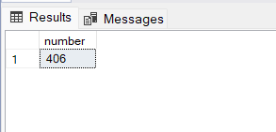

select count(*) as number from (

select * from van_host where host_name not in (select HOST_NAME from (

select a.host_id,a.host_name,b.name ,a.host_neighbourhood from van_host as a inner join van_list as b on

a.host_id=b.host_id

where a.host_neighbourhood =b.neighbourhood_cleansed ) as a)) as mo

where host_is_superhost='false'

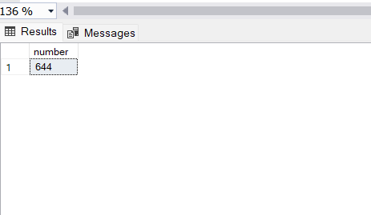

-----profile verified

---local

select * from van_local_host

select count(*) from van_local_host

select count(*) from van_local_host where host_has_profile_pic='true'

select count(*) from van_local_host where host_has_profile_pic='false'  
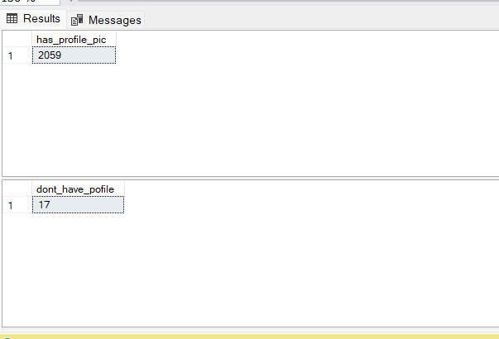

---other

select * from van_other_host

select count(*) from van_other_host

select count(*) from van_other_host where host_has_profile_pic='true'

select count(*) from van_other_host where host_has_profile_pic='false'

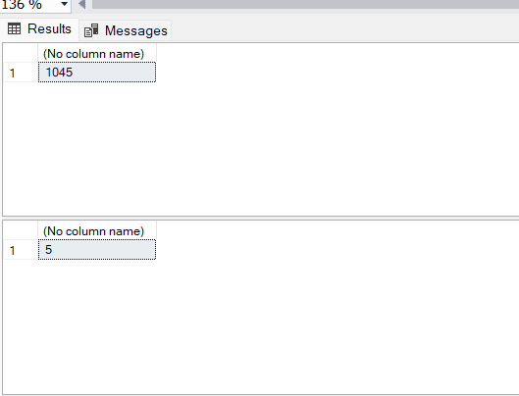

---listing

select avg(host_listings_count) as listing_for_local from van_local_host

select avg(host_listings_count) as listing_for_local from van_other_host

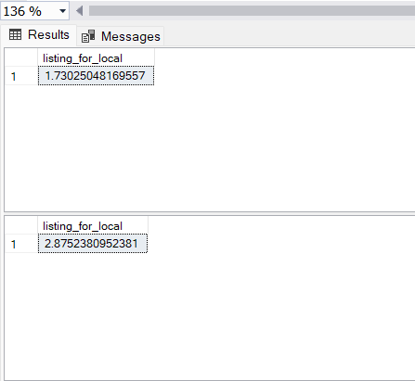

---Q7 Analyze the above trends for the two cities for which data has been provided and provide insights on comparison

Select Count(host_id) No_Of_host From toro_host Group BY host_is_superhost

Select Count(host_id) No_Of_host From van_host Group BY host_is_superhost

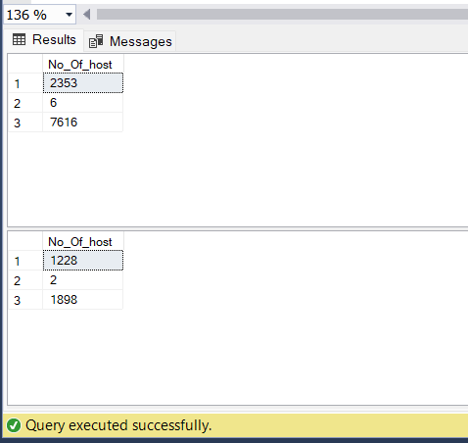

Select A.host_is_superhost,Count(B.id) total_listing From toro_host A inner join toro_list B

on A.host_id = B.host_id where A.host_is_superhost is not null

Group By A.host_is_superhost

Select A.host_is_superhost,Count(B.id) total_listing From van_host A inner join van_list B

on A.host_id = B.host_id where A.host_is_superhost is not null

Group By A.host_is_superhost  
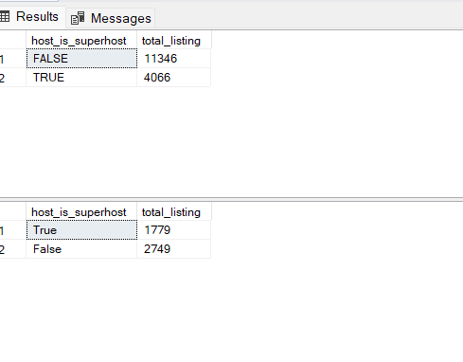

--torr avg price

Select*From(

Select Round(AVG(A.adjusted_price),0) Avg_Price,year(Date) Upcom_Year

From toro_avail A inner join toro_list B on A.listing_id = B.id

inner join toro_host C on B.host_id = C.host_id where A.available = 'true' and C.host_is_superhost is not null

Group By year(Date))z

Pivot (Avg(Avg_Price) For Upcom_Year in ([2022],[2023])) pvt1  
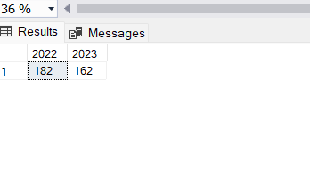

--Van avg price

Select*From(

Select Round(AVG(A.adjusted_price),0) Avg_Price,year(Date) Upcom_Year

From van_avail A inner join van_list B on A.listing_id = B.id

inner join van_host C on B.host_id = C.host_id where A.available = 'true' and C.host_is_superhost is not null

Group By year(Date))z

Pivot (Avg(Avg_Price) For Upcom_Year in ([2022],[2023])) pvt2

